
Sheffield Woman to Woman
Counselling and Psychotherapy

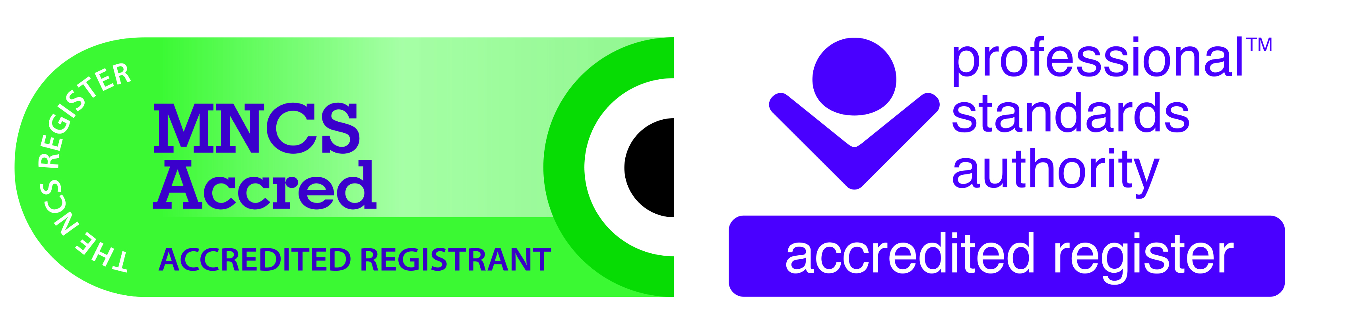
Cookie Policy April 2019
This website uses cookies to make it work efficiently. This includes analysing usage so that improvements can be made if necessary. Cookies are initially sent to your browser from web servers as messages. These messages are stored in a file on your web browser called a cookie.txt. As you visit another page on the website your browser sends the cookie back to the server. The cookie is sent back and forth to the server each time an HTTP request is made i.e. visiting different pages on the site or sending information etc. Information about your visit to the website is stored in these files. If you have given your name and contact details via the website this will also be sent as a cookie file to the server.
There are two types of cookies used by wix:
Session (Transient) cookies – These do not identify the user and are erased at the end of the session.
Persistent (Permanent or Stored) – These are stored on your hard drive until they expire or until you delete them. Information that may identify the user is stored in these such as how the Web is surfed and how a specific site is used.
The website provider for w2w is Wix. Below is the table they provide which states which cookies are used on their websites.
Cookie Name | Life Span | Purpose
sv Session | Persistent | Identifies unique visitors and tracks a visitor’s session on a site.
hs | Session | Security
XSRF-TOKEN | Persistent | Security
smSession | Persistent (two weeks) | Identifies logged in site members
TSxxxxxxxx (where x is replaced with a random series of numbers and letters). | Persistent | Security
TSxxxxxxxx_d (where x is replaced with a random series of numbers and letters). | Persistent | Security

Deleting Cookies
In Chrome you can delete your browsing data and cookies by going into settings/advanced/privacy and security. Other browsers will also have this option but it may be via a different route e.g. through the browser’s help and support tool. Further information about clearing cookies and blocking cookies can be found on the internet.
Wix
As the website provider Wix will have access to your IP address etc. Wix state that they operate lawfully under the UK GDPR regulations. To learn more about Wix then please visit their website and view their privacy policy.

Google Analyitics

Google Analytics is a third party on this website. This enables w2w to see how effectively the website is being used by its visitors and therefore what changes may need to be made. Although data is collected, the IP (Internet Protocol) addresses of visitors to the site are anonymised. Minimal sharing of data within Google analytics is permitted. Data collected by Google analytics is not permitted to be shared with a third party from this website.

Cookies on The Practice Rooms Website

If you click on the link to The Practice Rooms’ website these are the cookies they use and the reasons for them:

_ga
_gid
_gat_gtag_UA_102210756_1
practicerooms
These cookies are used in the following ways:
• to track how you use their website
• to keep you signed in their site

