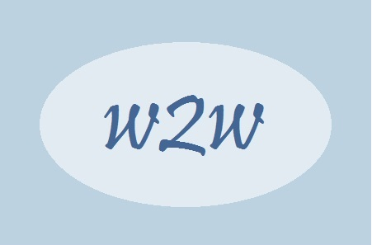
Sheffield Woman to Woman
Counselling and
Psychotherapy

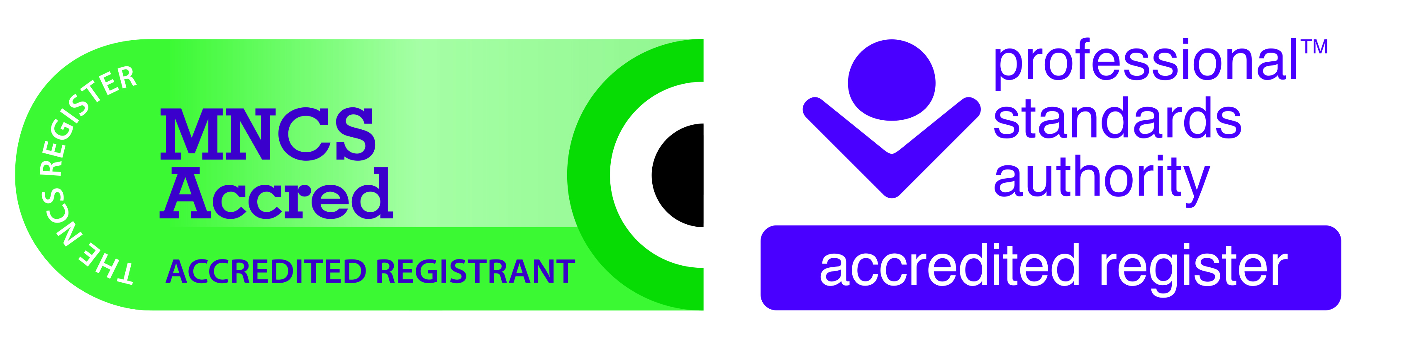

Confidentiality Statement June 2023
Limits to Confidentiality

What you discuss with your therapist at Woman to Woman (w2w) is confidential but with the following exceptions:
- Every therapist has supervision where some content of the therapy sessions is discussed to ensure best practice. This is a requirement of membership to the professional bodies. However, either just your first name or a pseudonym is used to protect your identity.

- If you disclose information pertaining to safeguarding:

- Child Protection
- Vulnerable Adults
- Acts of Terrorism
In this case the relevant statutory bodies will be informed.
- Confidentiality cannot be guaranteed during Counselling in the Countryside. However, steps are taken to try and make this as confidential as possible.
- If you are at immediate risk to yourself through suicide then your doctor will be informed. Ideally, this will be done with your knowledge and consent. However, if you do not give your consent at the time, your doctor will still need to be informed.

- If you pose a threat to others, including your therapist, then the relevant statutory bodies will be informed. This may be done without your knowledge depending on the circumstances and the level of risk.

- All measures will be taken to try and ensure confidentiality by Distance Therapy. However, this cannot be guaranteed as outlined in the privacy policy and contract.

- In the event of the death or incapacity of Clare Fillingham the professional executor of w2w will have the responsibility of the overall administration of w2w as stated in the privacy policy.

